Optical optimization potential of Transparent Passivated Contacts in Silicon Solar Cells

Alexander Eberst*, Alexandr Zamchiy, Kaifu Qiu, Peter Winkel, Habtamu T. Gebrewold, Andreas Lambertz, Weiyuan Duan, Shenghao Li, Karsten Bittkau, Thomas Kirchartz, Uwe Rau, Kaining Ding

Alexander Eberst, Kaifu Qiu, Peter Winkel, Habtamu T. Gebrewold, Andreas Lambertz, Weiyuan Duan, Shenghao Li, Karsten Bittkau, Thomas Kirchartz, Uwe Rau, Kaining Ding

IEK-5 Photovoltaics, Forschungszentrum Jülich GmbH, 52425 Jülich, Germany

E-Mail: a.eberst@fz-juelich.de

Alexander Eberst, Peter Winkel, Habtamu T. Gebrewold, Uwe Rau

Faculty of Electrical Engineering and Information Technology, RWTH Aachen University 52074 Aachen, Germany

Alexandr Zamchiy

Novosibirsk State University, 630090, Novosibirsk, Russia

Alexandr Zamchiy

Kutateladze Institute of Thermophysics SB RAS, 630090, Novosibirsk, Russia

Kaifu Qiu

Institute for Solar Energy Systems, Guangdong Provincial Key Laboratory of Photovoltaic Technology, School of Physics, Sun Yat-Sen University, Guangzhou, 510275, PR China

T. Kirchartz

Faculty of Engineering and CENIDE, University of Duisburg-Essen, Carl-Benz-Str. 199, 47057 Duisburg, Germany

Keywords: anti-reflective coatings, magnesium fluorides, passivating contacts, silicon carbides, silicon solar cells

We present an optical loss analysis of the recently introduced silicon carbide-based transparent passivating contact for silicon heterojunction solar cells, identify the most dominant losses and discuss the potential for reducing these losses. Magnesium fluoride is applied as anti-reflective coating to reduce the reflective losses by up to 0.8 mA/cm². When applying the magnesium fluoride, the passivation quality of the layer stack degrades, but is restored after annealing on a hot plate in ambient air. Afterwards, we present and discuss a roadmap for transparent passivating contact solar cells towards an efficiency of 25%. The largest part in efficiency gain is achieved by reducing the finger width and by increasing the passivation quality. Furthermore, we show that transparent passivating contact solar cells have the potential to achieve short-circuit current densities above 42 mA/cm² if the finger width is reduced and the front-side ITO layer can be replaced by an ITO-silicon nitride double layer.

1. Introduction

To keep the rise in efficiency of crystalline silicon (c-Si) solar cells going, a multitude of approaches are currently under investigation to realize the combination of spatial separation of the metal contacts from the silicon wafer and effective passivation of the c-Si surface, while also maximizing the incident light and keeping good contact properties. Promising approaches are the use of either polycrystalline silicon (poly-Si)[1] or hydrogenated amorphous silicon (a-Si:H)[2], called silicon heterojunction (SHJ), for passivation and charge carrier extraction purposes. Due to the absorption coefficient of these materials being similar to that one of crystalline silicon (c-Si), one severe limitation in these approaches is the large loss of incident light in these layers, called parasitic absorption[3, 4], and thus a limited short-circuit current density *J*SC. This parasitic absorption could be mitigated by the so-called Interdigitated Back Contact (IBC) approach, where both the electron and hole contact are placed on the not-illuminated rear side of the c-Si. By using this structure, the incident light is maximized and the parasitic absorption minimized, but the fabrication process of IBC cells is more complex.[5-7]

To keep the contacts at the illuminated side of the cell and thus the fabrication process simpler, a broad spectrum of materials is currently under investigation to fulfil the initially mentioned criteria. Metal compounds like zinc oxide or molybdenum oxide[8] or different silicon-based materials like microcrystalline silicon[9, 10] are promising approaches. Another silicon-based, highly transparent material is hydrogenated nanocrystalline silicon carbide (nc-SiC:H), which was recently introduced in a contact scheme called transparent passivating contact (TPC)[11]. The TPC combines a thin wet-chemically grown silicon oxide as tunnel oxide[12, 13] with a nitrogen-doped nc-SiC:H double-layer to achieve a high transparency in combination with excellent passivation, leading to a certified efficiency of 23.8% without an additional anti-reflective coating and 24.0% efficiency with said coating[11]. Additionally, the fabrication process of the TPC is very lean.[14]

This work focusses on the optical losses of the certified 23.8% efficiency TPC cell and identifies its mayor contributors. After the optical losses are identified, an in-depth analysis beyond the previous study[11] of the influence of MgF2 as anti-reflective coating is presented. We discuss the problems and present a possible solution, leading to the certified efficiency of 24.0%. In the following, we give a possible pathway to achieve efficiencies of 25% using TPC and elaborate on the potential of the TPC to reach a *J*SC of 42 mA/cm².

2. Optical properties and losses in the TPC cell

2.1. Optical Loss Analysis

**Figure 1** shows the optical loss analysis of the 23.8% TPC solar cell, as shown in **Figure S1**, without MgF2[11] according to Paviet-Salomon *et al.*[15]. For the loss analysis, we use in-house measured external quantum efficiency, reflectance (*R*cell) and transmission (*T*cell) curves of the cell, as well as reflectance curves which we simulate using the online tool OPAL2 (*R*OPAL2). We calculate the losses from finger shading from the finger geometry, as explained in the Supporting Information. While the absorption losses in the near infrared wavelength regime (2.4 mA/cm²) and the losses from finger shading (1.5 mA/cm²) are the most severe ones, the losses from front surface escape (1.1 mA/cm²) and reflection (0.8 mA/cm²), as well as the other wavelength dependent losses in the blue wavelength regime (0.6 mA/cm²) and intermediate wavelength regime (0.1 mA/cm²), also play a big role in reducing the *J*SC. No losses from transmission through the cell occur due to the fully metalized rear side of the cell.

While most of these losses are complicated to reduce since other solar cell parameters will also be influenced when changing the corresponding properties, we show how to reduce the reflection losses with a straightforward approach, which is to introduce an additional anti-reflective coating layer which reduces the refractive index difference between two adjacent layers, in this case the ITO and air. MgF2 is a suitable material, as already commonly used in SHJ cells to reduce the reflection[8], since it´s refractive index *n*MgF2 for wavelength from 300 nm to 1200 nm is between 1.3 and 1.4, which is between the refractive index of ITO with 1.62 ≤ *n*ITO ≤ 2.51 and air with *n*air = 1. Additionally, MgF2 has an absorption coefficient of nearly zero for visible light, thus the parasitic absorption will not increase significantly. The measurements are all conducted in air. It is expected that, in a module, the short-circuit current gain from MgF2 is likely less than in air, if there is any gain at all. Nevertheless, the use of MgF2 as anti-reflective coating shows the potential of the TPC and if the encapsulation material in a module can match the refractive index of MgF2, a similar effect might be achieved in a module as well.

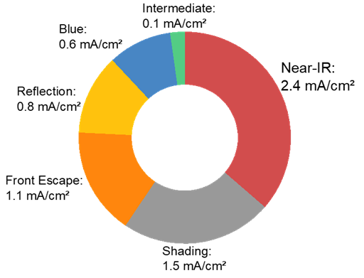

**Figure** **1.** Optical losses in the Transparent Passivating Contact cell according to Paviet-Salomon *et al.*[15]. The biggest contributors to the losses are the long-wavelength near-IR absorption losses, followed by losses from finger shading and front escape.

2.2. Optical Optimization

In **Figure 2**, it is shown that adding a MgF2-layer reduces the reflectance of a TPC test cell. The reflection is notably reduced below a wavelength of 500 nm and between 600 nm and 1000 nm. This reduction in reflection increases absorption and thus leads to a higher external quantum efficiency (EQE).

The calculated short-circuit current gain from the reduced reflection from the difference in the measured reflection curve is approximately 0.8 mA/cm², while the calculated short-circuit current gain in *EQE* only equals approximately 0.15 mA/cm². The lower short-circuit current gain in *EQE* than from the reduced reflection is an indication for a reduction in the quality of the passivation, which is also shown in the IV-parameters of the test cell in **Table 1**. There it can be seen that the *V*OC, the *pFF* and also the *FF* decrease, leading also to a reduction in efficiency after the MgF2 evaporation.

The lower short-circuit current gain and reduced *V*OC are signs for a lower passivation quality and could be explained by more unpassivated dangling bonds, which act as energetic states in the band gap of the c-Si surface. They act as traps for the charge carriers in which the carriers recombine. When more charge carriers recombine, for example through these trap states, the *V*OC and the generated current is reduced*,* possibly explaining the difference in calculated gain from the reflectance and *EQE*. The drop in *FF* can be explained by the drop in *pFF*, which also stems from the reduced passivation quality and thus enhanced recombination[16, 17]. A reduction caused by an increase in *R*S can be ruled out since *R*S is approximately constant, as can be seen for example in **Figure 3** e). A possible mechanism for the degradation of the passivation is given at the end of this chapter.

The TPC test cell was placed on a hot plate in ambient air for various times and temperatures after the MgF2 evaporation, as indicated on the x-axis of Figure 3. As shown in Figure 3, after the first annealing step, there is a large increase in *J*SC of 3.89 mA/cm² and only small increases in *FF* and *V*OC. *FF* and *V*OC have a significant increase of 1.44 %abs and 11 mV respectively after the second annealing step. Within the measurement error, the *V*OC, *J*SC and *FF* are constant for any further annealing step. The error in *FF* and fluctuation for the different annealing steps might be explained by the sheet resistance *R*S, which error is extraordinarily large and stems from the measurement tool. The recovered passivation can be seen in the increased *V*OC as well as the steady increase in effective lifetime *τ*eff, where an increased lifetime implies lower recombination losses and thus a better passivation.

As shown in previous studies[11], the first two annealing steps were then applied to the champion cell. The efficiency was improved from 23.8% to 24.0%, mainly by improving the *J*SC to 40.9 mA/cm² while maintaining the *FF* and the *V*OC. The in-house measured history for each cell parameter for each processing step of the test cell and the champion cell can be found in Table 1.

As a possible explanation we suggest that in the initial passivation directly after the nc-SiC:H(n) growth, atomic hydrogen introduced during the deposition process might passivate the dangling bonds of the crystalline silicon interface that are not bonded to oxygen of the SiOX tunnel oxide layer. The degradation of the passivation during the MgF2 evaporation could be due to cracking of silicon-hydrogen bonds at the crystalline silicon interface, leading to more dangling bonds and an increased recombination. It is very unlikely that particles reach the crystalline silicon interface during the MgF2 evaporation, since for example during a sputtering process oxygen ions with an energy of 1 keV would only penetrate approximately 4 nm into silicon[18]. The thermal energy *kT* of the MgF2 at the evaporation temperature *T*, calculated by using the melting point of MgF2, *T* = 1528 K[19] and *k* being the Boltzmann constant, is approximately 0.66 eV. One explanation could be thermally-induced cracking of the silicon-hydrogen bonds at the c-Si interface. Since no additional heater is used, the energy might come from impacting particles or radiation emitted from the sublimation process of the MgF2 and is then transported to the SiOX/c-Si interface by lattice vibrations, which can transport energies up to 75 meV[20]. The heat supplied during the annealing then restores some of the previously broken bonds. The underlying assumption is that a single hydrogen atom can´t persist and needs a bonding partner, in this case either a silicon dangling bond, saturating another silicon bond either at the c-Si interface, or from the SiOX, or another hydrogen, forming H2. Once detached from the silicon dangling bond of the crystalline silicon interface and, if bonded to another hydrogen atom, the H2 diffuses mostly along the c-Si interface, since SiO2 decreases the hydrogen diffusion significantly[21-23]. Since the oxide grown here is most likely under-stoichiometric[24, 25], some hydrogen might escape from the interface and is lost for passivation purposes. The other H2 molecules remain close to the dangling bonds of the c-Si interface and can be reused for passivation purposes when cracked during the annealing procedure, re-saturating said dangling bond. A schematic visualization of the resulting lifecycle on the hydrogen at the interface can be found in **Figure S4**.

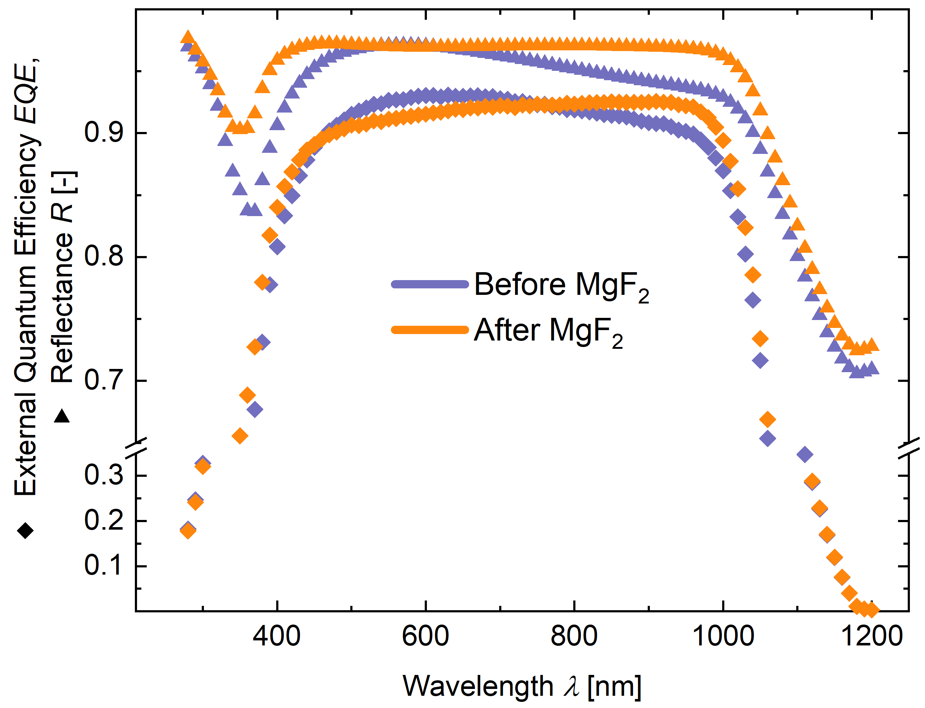

**Figure** **2.** Reflectance measurement and *EQE* measurement of the TPC before and after MgF2, but without any annealing. There is a mismatch from the calculated short-circuit current gain from the reduced reflection and the gain in *EQE*.

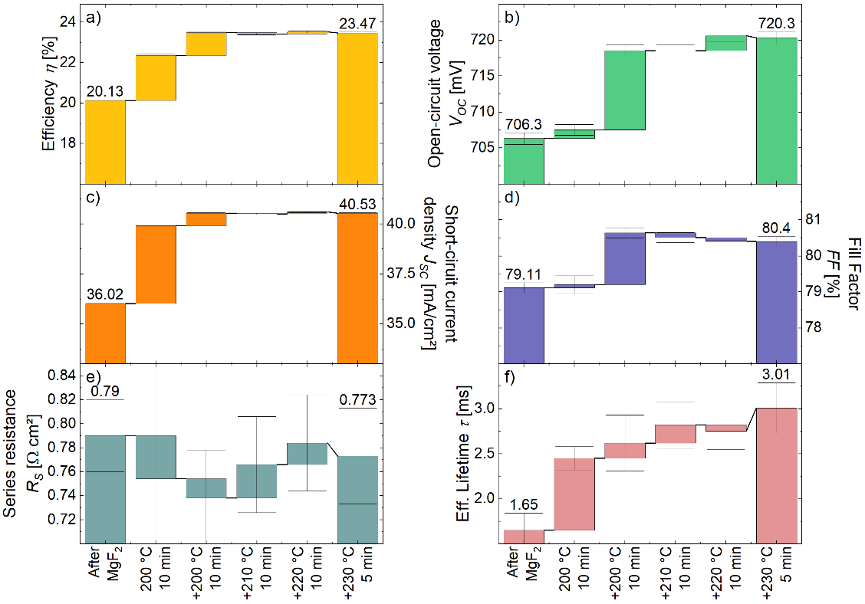

**Figure** **3.** (a) Efficiency *η*, (b) *J*SC, (c) *V*OC, (d) *FF,* (e) *R*Sand (f) *τ*eff of a TPC cell for different annealing steps on a hot plate in ambient air. The annealing time and temperature can be found on the *x*-axis After the first two annealing steps, we observe no further enhancement of the performance parameters of the solar cell .

**Table** **1.** In-house measured parameters for a TPC test solar cell and the champion cell before and after the MgF2 evaporation and after subsequent annealing. Also, the simulated cell data of the champion cell using Quokka 3 is shown.

|  |  |  |  |  |  |  |  |
| --- | --- | --- | --- | --- | --- | --- | --- |
|  | | Efficiency *η* [%] | *J*SC [mA/cm²] | *V*OC [mV] | *FF* [%] | *pFF* [%] | *R*S[Ω cm] |
| Test cell | Before MgF2 evaporation | 23.1 | 40.0 | 716 | 80.5 | 84.1 | 0.757 |
| After MgF2 evaporation | 22.6 | 40.2 | 710 | 79.3 | 82.9 | 0.791 |
| After annealing | 23.5 | 40.52 | 718 | 80.7 | 84 | 0.693 |
| Champion cell | Before MgF2 evaporation | 23.6 | 40.1 | 727 | 80.8 | 83.9 | 0.731 |
| After MgF2 evaporation | 23.8 | 40.9 | 723 | 80.4 | 83.8 | 0.732 |
| After annealing | 24.0 | 40.9 | 726 | 80.7 | 83.8 | 0.684 |
| Simulated champion cell (Quokka 3) | | 23.88 | 40.9 | 725.5 | 80.48 | - | 0.501 |

3. Potential of the TPC

3.1 Efficiency roadmap to 25%

We used the data from the certified solar cell with an efficiency of 24.0% from previous studies[11] as a base to find input parameters for a simulation using QUOKKA3 of the certified cell. The simulation allowed us to obtain further insights into losses of the solar cell and enables us to design a roadmap describing the path towards achieving efficiencies of 25% with TPCs. **Figure 4** presents the breakdown of the different losses resulting from our QUOKKA3 simulations. For the analysis, two main assumptions had to be made. The current losses were multiplied by the simulated voltage at the maximum power point to convert them in mW/cm² for an easier comparison between current (optical) losses and free energy (recombination, resistive) losses. The reflection losses were estimated from OPAL2 simulations and the absorption in the different layers was approximated from Lambert-Beer law. The optical losses are the most dominant ones with total losses of 3.38 mW/cm², whereas the total recombination losses are 1.49 mW/cm² and total resistive losses are 1.02 mW/cm². In the optical losses, 1.63 mW/cm² are lost by unabsorbed photons, while 0.97 mW/cm² are lost from finger shading. In the recombination losses, 0.78 mW/cm² is lost from recombination at the front c-Si interface and 0.42 mW/cm² at the rear c-Si interface. Unabsorbed photons are photons with energies above the band-gap *E*g, but with energies low enough that they are not fully absorbed during the pass-through of the silicon bulk. These photons are either reflected or parasitically absorbed, e.g. in the near-IR regime or at the metallization, and thus do not contribute to electron-hole pair generation. The individual resistive losses are all rather small.

Subsequently, we adapted the simulation of the base cell to decrease the mayor loss contributors to achieve a final efficiency of 25%. Note that the simulated base efficiency deviates slightly from the certified efficiency. This discrepancy is because most IV-parameters of the cell could be matched besides *R*S and thus a slight mismatch in *FF* could not be avoided. But as can be seen by the large error bars in Figure 3 e), the measured *RS* value are not too precise. Also, a slight deviation in the simulated and measured *V*OC could not be avoided.

The final roadmap can be found in **Figure 5**, where the changes in the simulation are marked. An extended explanation of the changed simulation parameters can be found in the Supporting Information. Reducing the finger width will reduce the losses from the finger shading and can be done by adjusting the screen-printing process. Simultaneously, the finger pitch needs to be adjusted to avoid losses in the *FF*. A balance between a reduced finger width for increasing the incident light and a smaller finger pitch to mitigate losses in the *R*S and *FF* needs to be found to increase the *J*SC and maintain the *FF*. The surface recombination velocity at the front c-Si surface *S*eff,front could be reduced by an additional hydrogenation step or optimization of the wet-chemical oxidation process of the SiOX. Preliminary experiments have already shown that an increase in implied *V*OC of up to 7 mV, suggesting a lower *S*eff,front, can be achieved by adjusting the concentrations of hydrogen peroxide and sulfuric acid during the wet-chemical oxidation of the wafers, probably changing the reaction kinetics and thus growing a more stoichiometric oxide. The bulk lifetime is determined by the quality of the wafers. The near-IR response can be increased by e.g., decreasing the near-IR absorption in the front stack. One possibility would be to replace the ITO with higher mobility TCO materials which have a better trade-off of optoelectrical performance, such as hydrogenated indium oxide (IO:H) or titanium doped indium oxide (ITiO). The absorptance of IO:H is equal to or lower than that of ITO, especially for wavelength above 600 nm[26]. The absorption coefficient of ITiO can be found in **Figure S2**. It is similar to that of ITO until wavelength of approximately 350 nm and significantly lower than that of ITO for wavelength above 350 nm. Here it is important that the electrical properties of the new TCO are similar to that of the ITO so that the gain from the previous optimization stays valid.

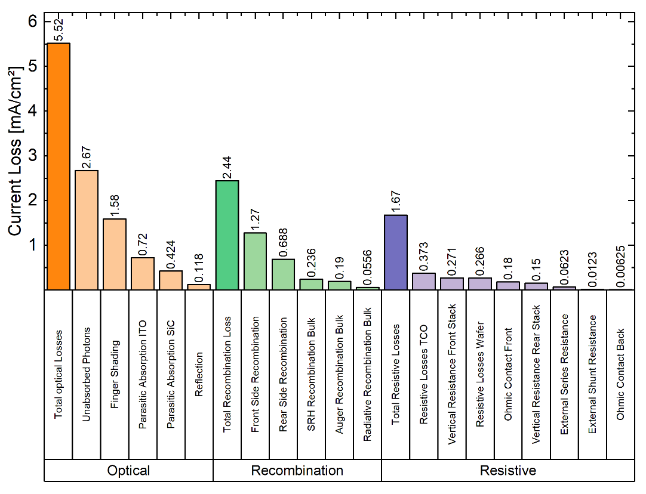

**Figure** **4** Loss Analysis using QUOKKA3 of the certified 24.0% cell from previous studies[11]. To see the influence of the losses on the short-circuit current density, the losses are given in mA/cm². If the tool gives the losses in mW/cm², they are divided by *V*MPP to estimate the losses in mA/cm².

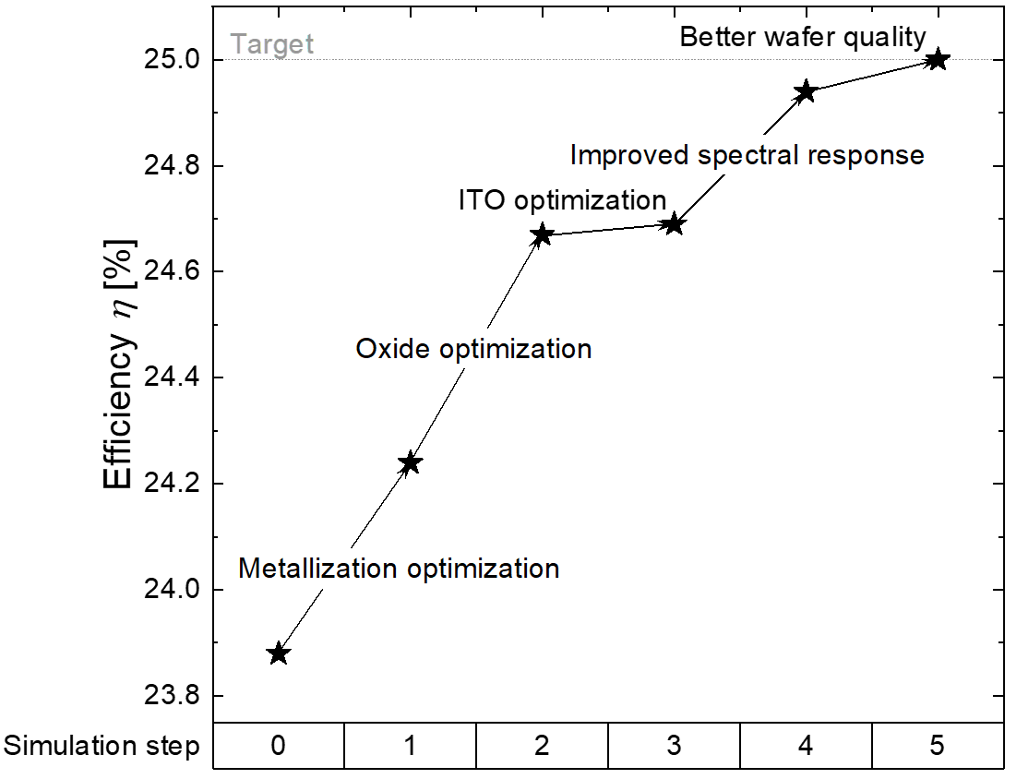

**Figure** **5.** Simulated roadmap to a solar cell efficiency of 25% with a TPC on the front side. The changes compared to the base simulation, which is of the certified 24.0% cell from previous studies[11], are noted in the graph. Adjusting the front finger structure and reducing *S*eff,front contribute most to an increased efficiency.

3.2. *J*SC potential of the TPC

Based on the certified cell in previous studies[11], the *J*SC can be optimized for a potential *J*SC,pot of 42 mA/cm². The biggest gain of the missing 1.1 mA/cm² can come from the reduced finger width and optimized finger pitch mentioned in the previous section. By halving the finger width from currently 60 μm to 30 μm, which is still doable by screen-printing or copper-plating, the simulations show a gain in *J*SC,pot of 0.6 mA/cm².

For the last 0.5 mA/cm², an optical Sentaurus TCAD simulation was performed to further optimize the *J*SC. **Figure 6** a) shows the potential of improving the efficiency by optimizing the ITO. With an original ITO thickness of 70 nm and 120 nm of MgF2, 0.82 mA/cm² is parasitically absorbed in the front ITO, while 2.16 mA/cm² is lost by reflection, as shown in Figure 6 c). When the ITO thickness is reduced and the MgF2 thickness is adjusted accordingly, the parasitic absorption is reduced but the anti-reflective properties of the ITO are decreased as well, also leading to a higher reflection loss of 2.34 mA/cm². When optimizing the *J*SC,pot gain from reduced parasitic absorption versus the *J*SC,pot loss from the increased reflectance, a total gain of 0.29 mA/cm² can be achieved, originating from reducing parasitic absorption in the ITO to 0.37 mA/cm² with an increased reflection loss of 2.36 mA/cm², as shown in Figure 6 d) compared to Figure 6c). The total gain by only an optimized ITO layer thickness is insufficient to achieve a theoretical *J*SC,pot of 42.00 mA/cm² because of the inherent trade-off between anti-reflective properties and parasitic absorption. Fortunately, in a broad wavelength regime, silicon nitride (SiNx) has a comparable refractive index (as shown in **Figure S3**) to ITO when grown under the right conditions[27]. Unlike ITO, the absorption coefficient of SiNx is negligible. When the ITO layer is set to 10 nm to reduce the parasitic absorption and still maintain some of the electrical properties, Figure 6 b) shows that an additional 55 nm of SiNX in combination with 110 nm MgF2 are needed for optimal anti-reflective properties. Figure 6 e) shows that with the ITO/SiNX/MgF2 ARC, the parasitic absorption can be reduced to 0.12 mA/cm² while maintaining the low reflection losses from the current case. According to the simulations, this would enable an additional gain in *J*SC of 0.65 mA/cm², for a total *J*SC,pot,max of 42.15 mA/cm². Unfortunately, the sheet resistance of the ITO increases with decreasing thickness. According to electrical simulations this leads to a reduced *FF* of 79.43% and 77.63% for 30 nm and 10 nm ITO, respectively. The gain in *J*SC can´t completely compensate the lower *FF* and the efficiency is reduced to 23.7% and 23.3% for 30 nm and 10 nm ITO, respectively. This could be counteracted by further optimizing the conductivity of the conductive nc-SiC:H(n) layer[28]. Li *et al.* have shown that the TCO can be completely omitted and that the c-Si wafer ca be used for lateral conduction if the contact resistance is sufficiently low[29].

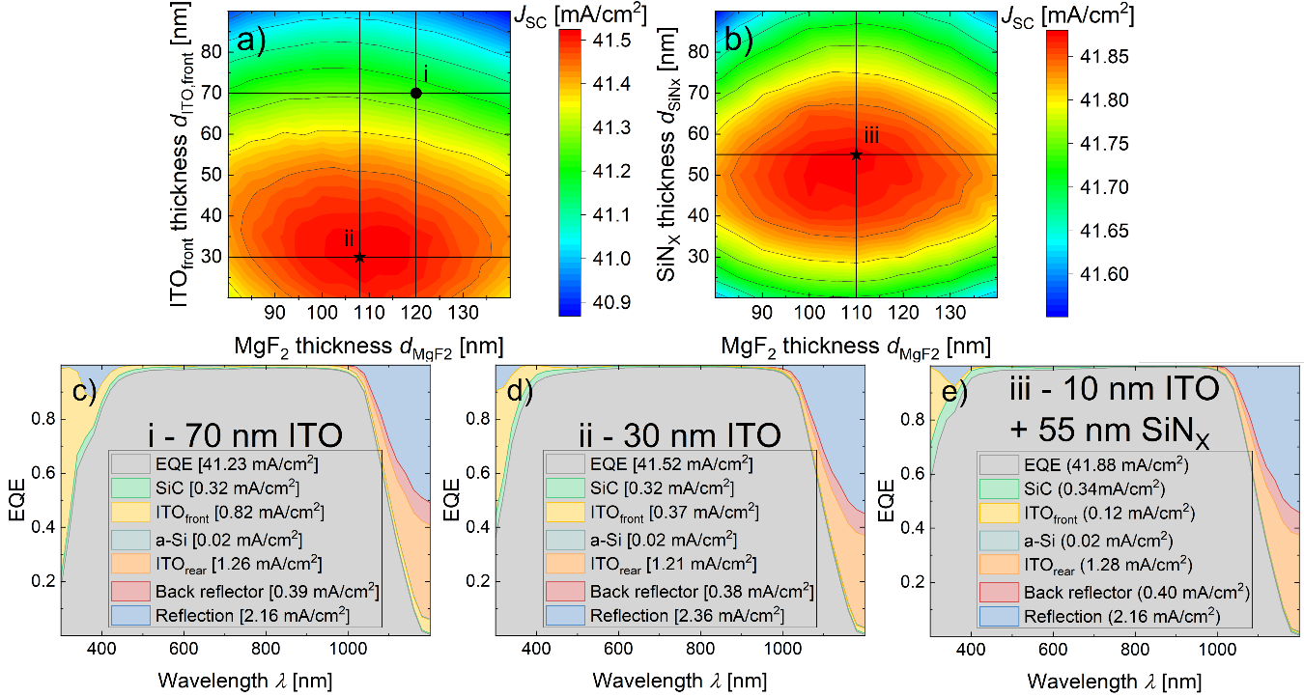

**Figure** **6.** Sentaurus TCAD simulations for the optical optimization of a cell using the TPC on the front side. a) Heatmap of the *J*SC depending on the thickness of the ITO and of the MgF2. The previously used thicknesses are marked with a circle, while the thicknesses for optically optimized layers are marked with a star. b) Heatmap of the *J*SC depending on the thickness of SiNX and MgF2 with 10 nm of ITO under the SiNX. The *J*SC-optimized layer thicknesses are marked with a star. c)-e) Simulated optical losses for each layer for the current layer thicknesses (c), the optimized thicknesses using only ITO (d), and the optimized thicknesses using the layer stack ITO(10nm)/SiNX/MgF2 (e). By reducing the ITO thickness and adding 55 nm SiNX as ARC, a gain in *J*SC of 0.65 mA/cm² can be achieved.

4. Conclusion

In this work, the optical losses of the recently introduced TPC [11] are analyzed using numerical simulations and experiments. An anti-reflective MgF2 layer, which has a refractive index between that of ITO and air, can reduce the reflective losses, which constitute a significant fraction of the overall optical losses.

We observe experimentally that evaporating the anti-reflective layer onto the cell reduces its *V*OC and *pFF*. Furthermore, the calculated gain from the reduced reflection is lower than the calculated gain from a higher *EQE*. These reductions can be explained by a reduced quality of the passivation, probably attributed to the hydrogen distribution. After annealing two times at 200 °C in ambient air for 10 minutes, the reduced parameters can be recovered. After curing, a high *J*SC of 40.9 mA/cm² can be achieved.

We perform a full loss analysis, including optical, recombination and resistive losses, using the simulation tool QUOKKA3. This analysis identifies the optical losses as the most severe ones. Based on this loss analysis, a possible pathway for an efficiency of 25% using nc-SiC:H(n) front contacts is designed, where the biggest gains in efficiency come from a reduced front finger width and a reduced recombination velocity at the front c-Si surface from a better passivation. When halving the finger width, adjusting the finger pitch and, based on Sentaurus TCAD simulations, reducing the thickness of the ITO while adding a silicon nitride layer as additional ARC, a *J*SC > 42 mA/cm² could be achieved.

5. Experimental Methods

The fabrication of the certified cells is described elsewhere[11], but a short introduction is given in the Supporting Information. The external quantum efficiency (*EQE*), Reflectance (*R*) curves and IV-parameters are measured with the LOANA system from pv-tools GmbH under standard test conditions. The implied *V*OC (i*V*OC) and pseudo FF (*pFF*), which is the Fill Factor (*FF*) without contributions from resistive effects, are measured with a Sinton WTC-120 lifetime tester in quasi steady-state conditions. The reflectance curve used as input for QUOKKA3 was simulated using the freeware-tool OPAL2[30-32], the roadmap was designed using the software QUOKKA3[33-36] and the *J*SC optimization was done using the software Sentaurus TCAD. In the Sentaurus TCAD simulations, raytracing with transfer matrix method boundaries was applied to simulate the optical response of the device. The optical properties of the involved materials were taken from spectroscopic ellipsometry measurements and the layer thicknesses were adjusted to achieve the best agreement with measured external quantum efficiency. The optical simulation results are then used as an input for the electrical simulation of the device. A 2D input optical generation profile is calculated from the total photon absorption in a c-Si layer of the 3D optical simulation result. In the 2D electrical device simulation, a non-local tunneling model as, implemented in Sentaurus TCAD, is used to model the carrier transport through tunneling thin oxide layer, whereas for the rear side, i.e. amorphous silicon and ITO contact, band-to-band tunneling is considered. Furthermore, a contribution of trap-assisted tunneling is included in amorphous silicon layers. The implemented 2D electrical device model has given a good agreement with experiment for the certified 24 % cell.

Further details on the simulation model set-up and parameters used can be found in literature[37]. Note that for this work measured electrical conductivity (σ) of the passivation and conductive silicon carbide layers, 5E-09 S cm-1 and 5E-01 S cm-1, respectively, are used. And, tunneling effective masses used for the oxide barrier are 0.4*m0 and 0.32*m0 for electrons and holes, respectively, as in literature[38]. m0 stands for the rest mass of an electron. The initial optical loss analysis was performed using a method proposed by Paviet-Salomon et al.[15].

**Supporting Information**

Supporting Information is available from the Wiley Online Library or from the author.

Acknowledgements

The authors gratefully acknowledge the funding of the German Federal Ministry of Economic Affairs and Energy in the framework of the TUKAN project (grant: 0324198D). The work of A. Zamchiy was supported in part by the German Academic Exchange Service (DAAD) and in part by the Ministry of Science and Higher Education of the Russian Federation, under Project 3.13378.2019/13.2.

Received: ((will be filled in by the editorial staff))  
Revised: ((will be filled in by the editorial staff))  
Published online: ((will be filled in by the editorial staff))

References

[1] S. W. Glunz, B. Steinhauser, J. I. Polzin, C. Luderer, B. Grübel, T. Niewelt, A. M. O. M. Okasha, M. Bories, H. Nagel, K. Krieg, F. Feldmann, A. Richter, M. Bivour, M. Hermle, *Progress in Photovoltaics: Research and Applications* **2021**.

[2] W. Duan, A. Lambertz, K. Bittkau, D. Qiu, K. Qiu, U. Rau, K. Ding, *Progress in Photovoltaics: Research and Applications* **2021**.

[3] Z. C. Holman, A. Descoeudres, L. Barraud, F. Z. Fernandez, J. P. Seif, S. De Wolf, C. Ballif, *IEEE Journal of Photovoltaics* **2012,** *2*, 7.

[4] S. Reiter, N. Koper, R. Reineke-Koch, Y. Larionova, M. Turcu, J. Krügener, D. Tetzlaff, T. Wietler, U. Höhne, J.-D. Kähler, *Energy Procedia* **2016,** *92*, 199.

[5] T. G. Allen, J. Bullock, X. B. Yang, A. Javey, S. De Wolf, *Nature Energy* **2019,** *4*, 914.

[6] K. Sopian, S. L. Cheow, S. H. Zaidi, *4th International Conference on the Advancement of Materials and Nanotechnology (Icamn Iv 2016)* **2017,** *1877*, 020004.

[7] A. Louwen, W. van Sark, R. Schropp, A. Faaij, *Solar Energy Materials and Solar Cells* **2016,** *147*, 295.

[8] Y. Q. Liu, Y. J. Li, Y. L. Wu, G. T. Yang, L. Mazzarella, P. Procel-Moya, A. C. Tamboli, K. Weber, M. Boccard, O. Isabella, X. B. Yang, B. Q. Sun, *Materials Science & Engineering R-Reports* **2020,** *142*, 100579.

[9] G. Nogay, J. P. Seif, Y. Riesen, A. Tomasi, Q. Jeangros, N. Wyrsch, F. J. Haug, S. De Wolf, C. Ballif, *IEEE Journal of Photovoltaics* **2016,** *6*, 1654.

[10] J. P. Seif, A. Descoeudres, G. Nogay, S. Hanni, S. M. de Nicolas, N. Holm, J. Geissbuhler, A. Hessler-Wyser, M. Duchamp, R. E. Dunin-Borkowski, M. Ledinsky, S. De Wolf, C. Ballif, *IEEE Journal of Photovoltaics* **2016,** *6*, 1132.

[11] M. Köhler, M. Pomaska, P. Procel, R. Santbergen, A. Zamchiy, B. Macco, A. Lambertz, W. Duan, P. Cao, B. Klingebiel, S. Li, A. Eberst, M. Luysberg, K. Qiu, O. Isabella, F. Finger, T. Kirchartz, U. Rau, K. Ding, *Nature Energy* **2021,** *6*, 529.

[12] M. Kohler, M. Pomaska, F. Lentz, F. Finger, U. Rau, K. Ding, *ACS Appl Mater Interfaces* **2018,** *10*, 14259.

[13] M. Köhler, A. Zamchiy, M. Pomaska, A. Lambertz, F. Lentz, W. Duan, V. Smirnov, F. Finger, U. Rau, K. Ding, *2018 IEEE 7th World Conference on Photovoltaic Energy Conversion (WCPEC)(A Joint Conference of 45th IEEE PVSC, 28th PVSEC & 34th EU PVSEC)* **2018,** 3468.

[14] M. Kohler, M. Pomaska, A. Zamchiy, A. Lambertz, W. Duan, F. Lentz, S. Li, V. Smirnov, T. Kirchartz, F. Finger, U. Rau, K. Ding, *IEEE Journal of Photovoltaics* **2020,** *10*, 46.

[15] B. Paviet-Salomon, A. Tomasi, A. Descoeudres, L. Barraud, S. Nicolay, M. Despeisse, S. De Wolf, C. Ballif, *IEEE Journal of Photovoltaics* **2015,** *5*, 1293.

[16] A. C. Bournazou, A. Cruz Bournazou, *Transparent Conductive Oxides for Silicon Heterojunction Solar Cells: Interaction between Materials and Device*, **2020**

[17] M. A. Leilaeioun, *Fill Factor Loss Mechanisms: Analysis and Basic Understanding in Silicon Hetero-junction Solar Cells*, Arizona State University, **2018**

[18] O. Kabadayi, H. Gumus, *Physica Status Solidi B-Basic Solid State Physics* **2005,** *242*, 2391.

[19] A. Duncanson, R. W. H. Stevenson, *Proceedings of the Physical Society of London* **1958,** *72*, 1001.

[20] B. Dorner, H. Schober, A. Wonhas, M. Schmitt, D. Strauch, *European Physical Journal B* **1998,** *5*, 839.

[21] W. Beyer, U. Zastrow, *Journal of Non-Crystalline Solids* **2000,** *266*, 206.

[22] W. B. Jackson, N. M. Johnson, C. C. Tsai, I. W. Wu, A. Chiang, D. Smith, *Applied Physics Letters* **1992,** *61*, 1670.

[23] N. H. Nickel, W. B. Jackson, I. W. Wu, C. C. Tsai, A. Chiang, *Phys Rev B Condens Matter* **1995,** *52*, 7791.

[24] A. Moldovan, F. Feldmann, K. Kaufmann, S. Richter, M. Wemer, C. Hagendorf, M. Zimmer, L. Rentsch, M. Hermle, *2015 IEEE 42nd Photovoltaic Specialist Conference (Pvsc)* **2015**.

[25] A. Moldovan, F. Feldmann, G. Krugel, M. Zimmer, J. Rentsch, M. Hermle, A. Roth-Folsch, K. Kaufmann, C. Hagendorf, *Proceedings of the 4th International Conference on Crystalline Silicon Photovoltaics (Siliconpv 2014)* **2014,** *55*, 834.

[26] M. Boccard, N. Rodkey, Z. C. Holman, *Proceedings of the 6th International Conference on Crystalline Silicon Photovoltaics (Siliconpv 2016)* **2016,** *92*, 297.

[27] S. Nunomura, I. Sakata, A. Sato, M. Lozac'h, T. Misawa, N. Itagaki, M. Shiratani, *Journal of Physics and Chemistry of Solids* **2021,** *156*.

[28] M. Pomaska, J. Mock, F. Köhler, U. Zastrow, M. Perani, O. Astakhov, D. Cavalcoli, R. Carius, F. Finger, K. Ding, *Journal of Applied Physics* **2016,** *120*, 225105.

[29] S. Li, M. Pomaska, A. Lambertz, W. Duan, K. Bittkau, D. Qiu, Z. Yao, M. Luysberg, P. Steuter, M. Köhler, *Joule* **2021,** *5*, 1535.

[30] S. C. Baker-Finch, K. R. McIntosh, *Progress in Photovoltaics* **2011,** *19*, 406.

[31] S. C. Baker-Finch, K. R. McIntosh, *35th IEEE Photovoltaic Specialists Conference* **2010,** 2184.

[32] K. R. McIntosh, S. C. Baker-Finch, *2012 38th IEEE Photovoltaic Specialists Conference (Pvsc)* **2012,** 265.

[33] A. Fell, P. P. Altermatt, *IEEE Journal of Photovoltaics* **2018,** *8*, 1443.

[34] A. Fell, K. R. McIntosh, K. C. Fong, *IEEE Journal of Photovoltaics* **2016,** *6*, 611.

[35] A. Fell, J. Schon, M. Muller, N. Wohrle, M. C. Schubert, S. W. Glunz, *IEEE Journal of Photovoltaics* **2018,** *8*, 428.

[36] A. Fell, J. Schon, M. C. Schubert, S. W. Glunz, *Solar Energy Materials and Solar Cells* **2017,** *173*, 128.

[37] H. T. Gebrewold, K. Bittkau, K. Qiu, K. Ding, *2021 IEEE 48th Photovoltaic Specialists Conference (PVSC)* **2021,** 1115.

[38] P. Procel, P. Löper, F. Crupi, C. Ballif, A. Ingenito, *Solar Energy Materials and Solar Cells* **2019,** *200*, 109937.

((**For Reviews and Perspectives,** please insert author biographies and photographs here for those authors who should be highlighted, max. 100 words each))

Author Photograph(s) ((40 mm broad, 50 mm high, color or grayscale))